QUEATION SOLVE 2021
Set-A
1.a) ﻿ Explain weighted, non-weighted, and unit-distance codes for representing decimal numbers with examples.
Weighted Codes:
Weighted codes assign different weights to each bit position in the binary representation. These weights are typically powers of 2. The value of each bit is determined by multiplying the bit value (0 or 1) with its corresponding weight and summing up these weighted values.
Example:
Let's consider a 4-bit weighted code where the weights are assigned as follows: W3 = 8, W2 = 4, W1 = 2, W0 = 1.
Decimal number 6 = 0110 in binary.
Binary representation: 6 = 0 * 8 + 1 * 4 + 1 * 2 + 0 * 1 = 6
Non-Weighted Codes:
Non-weighted codes do not follow a specific weight pattern for their bit positions. Each bit represents a certain value independently of its position. These codes are simple but less efficient in terms of encoding information compared to weighted codes.
Example:
Binary number 1010.
Decimal representation: 1010 = 1 * 2^3 + 0 * 2^2 + 1 * 2^1 + 0 * 2^0 = 8 + 0 + 2 + 0 = 10
Unit-Distance Codes:
Unit-distance codes are binary codes where only one bit changes between consecutive numbers. This property makes them useful in error detection and correction applications, as small errors in transmission are likely to flip only a single bit.
Example:
Let's use a unit-distance code for representing decimal numbers:
Decimal 3 = 0011 in binary
Decimal 4 = 0100 in binary
Decimal 5 = 0101 in binary
In unit-distance codes, each number differs from the previous one by only one bit.
1.b) Given two 8-bit 2's complement binary number A = ${(00101101)}_{2}$ and B = ${(11011010)}_{2}$. Compute C=A-B and verify the result by converting A, B, and C into decimal.
Done

1.c) How parity bit can be used for single-bit error detection? Explain with an example.
Parity Bit Method : A parity bit is an extra bit included in binary message to make total number of 1’s either odd or even. Parity word denotes number of 1’s in a binary string. There are two parity system – even and odd parity checks.
There are two common types of parity: even parity and odd parity.
Even Parity: The total number of set (1) bits, including the parity bit, should be even.
Odd Parity: The total number of set (1) bits, including the parity bit, should be odd.
Example: A parity bit, added to data, counts set bits for even or odd parity. Example: Data 1011 with even parity becomes 10110. If received data's parity doesn't match set bit count, a single-bit error is detected, e.g., 11110 indicates error.

2.a) Draw a circuit diagram to implement an Exclusive-OR gate using four NAND gates.
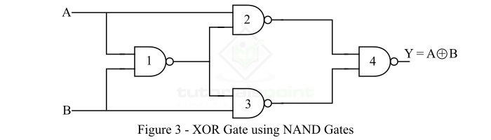
As discussed above, the NAND gate is a universal logic, hence, using which we may implement any other logic gate. Figure-3 shows how you can implement a XOR gate using only NAND gates.

From the logic circuit diagram of the XOR gate using NAND gates only, it is clear that we require 4 NAND gates.

2.b) Design a circuit diagram for converting BCD code into 2-out-of-5 code.
2.c) Prove i) y + xy’z’ + xz = x + y and ii) (x + y)’z + xy’ = y’(x + z) using Boolean algebra properties.
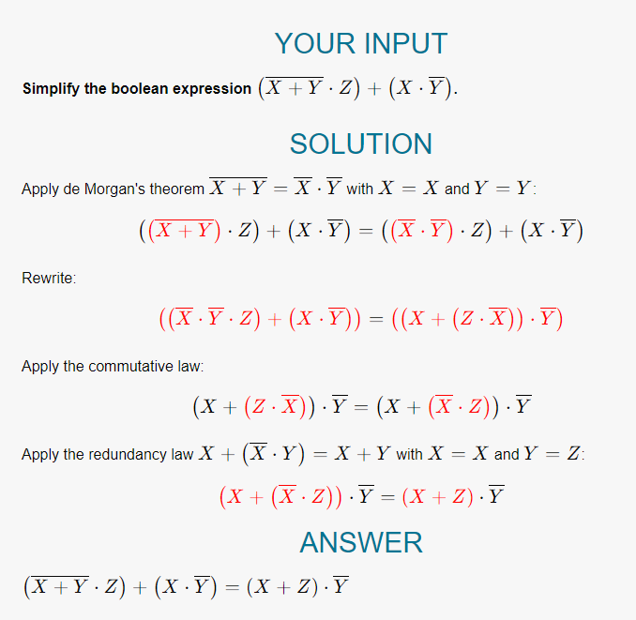
http://surl.li/kbnwo [algebra simplification calculator link]
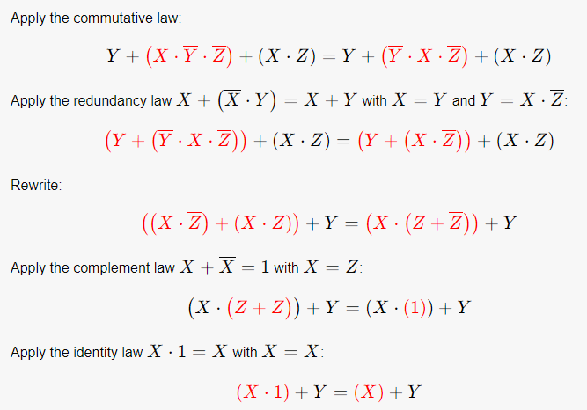

3.a) i) Write down the truth table for a half adder.
ii) Derive the logic circuit from the truth table of a half adder.
iii) Draw a full adder circuit by using two half adders.

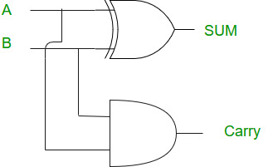
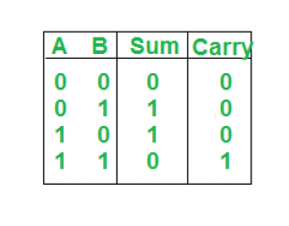
i) ii)

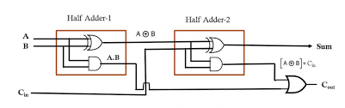

iii)

3.b) What is the basic difference between a parallel adder and a serial adder? Draw the timing diagram of a 4-bit parallel adder.
Serial Adders process one bit at a time, while Parallel Adders process all bits simultaneously. The choice of which type of adder to use depends on the specific application, and the designer must balance factors such as speed, complexity, and power consumption.
Parameters | Serial Adder | Parallel Adder
Addition manner | It is used to add two binary numbers in serial form. | It is used to add two binary numbers in parallel form.
Type of Registers | A serial adder uses shift registers. | A parallel adder uses registers with parallel loads.
Requirement | It requires a single full adder. | It requires multiple full adders.
Usage of | A carry flip-flop is used in the serial adder. | Ripple carry adder is used in the parallel adder.
Circuit Type | A serial adder is a sequential circuit. | A parallel adder is a combinational circuit.
Propagation Delay | In serial adder, propagation delay is less. | In parallel adder, propagation delay is present from input carry to output carry.
Speed | The serial adder has a slow speed as compared to the parallel adder. | The parallel adder has fast speed as compared to the serial adder.
Addition process | The addition process is carried out bit by bit. Therefore, addition time relies on bit count. | The addition process is carried out simultaneously. That implies all bits sum up simultaneously. Therefore, time does not rely on bit count.
Requirement of Components | It necessitates fewer components. | It necessitates more components because of design complexity.
Number of Full Adders | The number of required full adders is fixed i.e. one. | The number of required full adders is equal to the number of bits in the binary number.

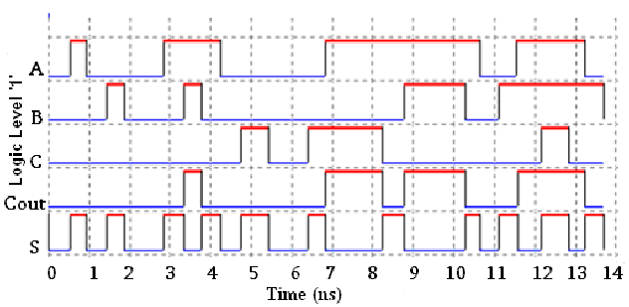

3.c) Implement a logic circuit for a 1-bit comparator and draw its truth table State the truth table and circuit diagram of a 1-bit binary comparator.

we can implement a logic circuit for this comparator as given below.
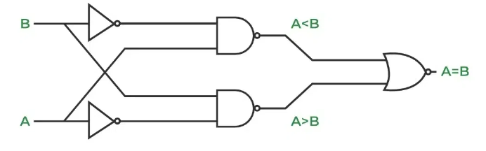

The truth table for a 1-bit comparator is given below.
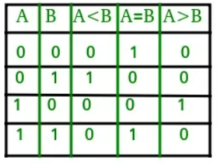
A comparator used to compare two bits is called a single-bit comparator. It consists of two inputs each for two single-bit numbers and three outputs to generate less than, equal to, and greater than between two binary numbers.
From the above truth table logical expressions for each output can be expressed as follows.
A>B: AB'
A<B: A'B
A=B: A'B' + AB

4.a) Design the circuit diagram of a BCD to 7-segment decoder.
4.b) Implement the following Boolean expressions using a 74LS138 3-to-8-line decoder.
${Y }_{1}$= A’B’+ AC + A’C’; ${Y }_{2}$ = A’C + AC’; ${Y }_{3}$= B’C + BC’;
4.c) Write some typical applications of multiplexer and demultiplexer.

Set-B
﻿

5.a) Differentiate between i) combinational and sequential logic circuits, ii) synchronous and asynchronous logic circuits.
5.b) Define setup time and hold time with necessary diagram.
5.c) Explain D flip-flop with asynchronous Preset and Clear input signals with block diagram, truth table, and timing diagram.

6.a) Mention the different modes of operations of the shift register. Draw the block diagram of 4-bit serial input serial output shift register, discuss its operation, and draw the truth table and waveforms. Draw the circuit diagram of a 4-bit serial in/parallel out and parallel in/serial out shift registers.
6.b) Classify counters in shift registers. Explain the operation of Johnson Counter in brief.

7.a) Draw the HDL design flow.
7.b) State the Verilog HDL supported levels of abstraction for designing digital circuits.
7.c) Write HDL code to implement a 4-to-2 line priority encoder.

8.a) Explain the port connection rules of Verilog HDL.
8.b) Define rise, fall, and turn-off delays with necessary diagram.
8.c) Draw the timing diagram of the following simulate module.

module comb_circuit(x, v);  input [3:0]v;  output x;  nor #5 (n,v[3],v[2]);  and #10 (a,v[1],v[0]);  xor #5 (x,n,a);  endmodule | module simulate;  reg [3:0]V; wire X;  comb_circuitct(X, V);  initial  begin  V=4'b0000;  #25 V=4'b0110;  #25 V=4'b0011;  # 25 V=4'b1011;  end  endmodule

